AI ML ASSIGNMENT - BOTBRAIN
WEEK 3 & WEEK 4 REPORT

WEEK 3 REPORT

1. Chatbot Interface & NLP
What I did: Developed a chatbot interface inside the Streamlit frontend with a floating toggle button and popup. Integrated Google Gemini Flash API with the FastAPI backend (`/chat` endpoint). Implemented a custom text-processing function (`extract_navigation_request`) using regular expressions to identify 'from' and 'to' locations in user messages.
How I met the requirement: The chatbot can handle free-text queries like “Navigate from Hostel to Admin Block” and return meaningful responses.

2. Navigation Module
What I did: Built the backend `/navigate` endpoint that supports BFS, DFS, UCS, and A*. Added distance calculation and estimated walking time (`total_distance`, `estimated_time`). Implemented a function to retrieve building info dynamically for each node in the path.
How I met the requirement: Users can select any two locations from dropdowns and choose a search algorithm. The system displays path details (distance, time, and building info). Results are also plotted on an interactive Folium map in Streamlit.

3. Data Handling
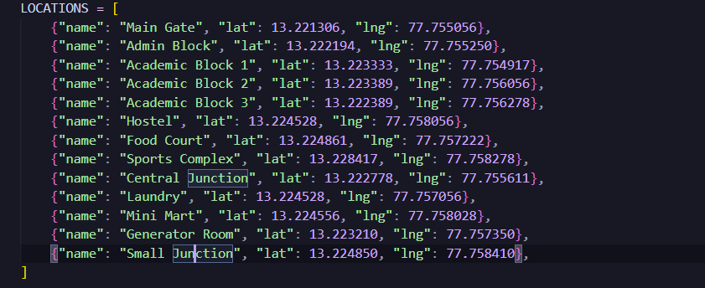
What I did: Represented the campus as a graph using building nodes and weighted edges. Used Python dictionaries for storing coordinates and metadata (like building descriptions).
How I met the requirement: The system can query building data, retrieve coordinates, and display location info. Successfully provides visual markers and path overlays on the map

Deliverables
- Integrated Backend + Frontend (FastAPI + Streamlit)
- Navigation System with BFS, DFS, UCS, and A*
- Working Chatbot powered by Gemini
- Map Visualization with Folium markers and paths
- Space for attaching source code snapshots here:

WEEK 4 REPORT

Testing & Finalization

1. Testing & Accuracy
What I did: Ran multiple navigation queries across all 12+ campus locations. Validated distances and routes for correctness. Compared algorithms on efficiency and node expansions.
How I met the requirement: BFS and DFS provided valid paths but were less efficient. UCS and A* consistently produced the shortest distance paths. A* expanded fewer nodes, proving to be the best-performing algorithm.

2. UI Refinement
What I did: Styled the Streamlit frontend with a dark theme. Added error handling Improved output formatting with highlighted navigation details.
How I met the requirement: Clear, user-friendly UI with dropdowns for path selection. Floating chatbot toggle with conversation history. Dynamic error messages and status indicators improve usability.

3. Final Report & Documentation
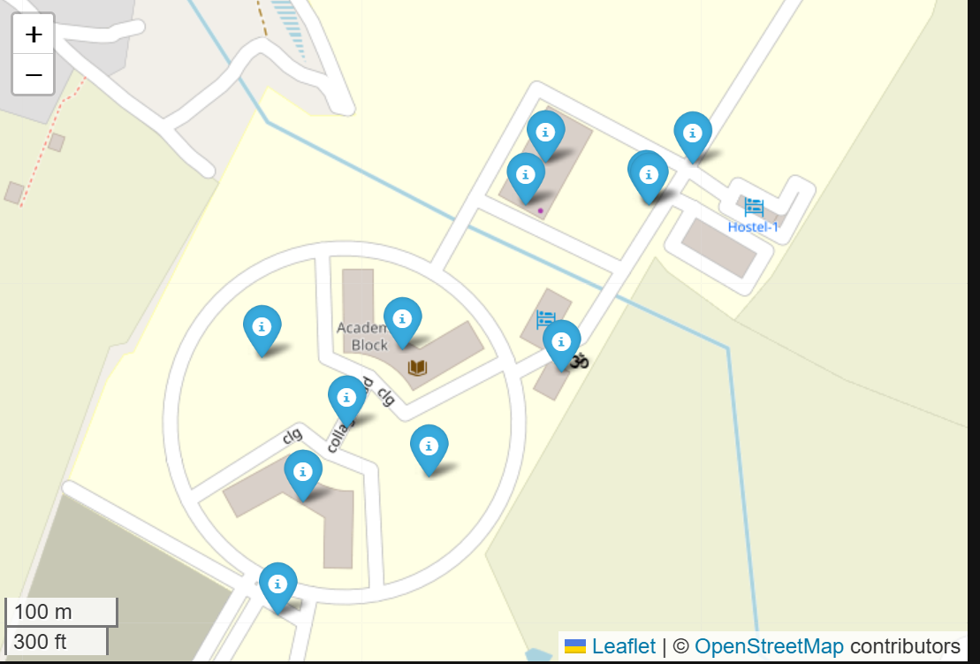
What I did: Prepared full technical documentation including PEAS analysis, system architecture, and algorithm explanations. Added requirements.txt files for both backend and frontend. Created a clear README for GitHub submission.
How I met the requirement: Deliverables (code, docs, demo) match assignment requirements. Presentation prepared with system overview, algorithm demonstration.

Deliverables
- Fully Functional Prototype (Campus navigation + chatbot)
- Algorithm Comparison (BFS, DFS, UCS, A*)
- Documentation (Final Report, README, requirements)
- Working Demo ready for submission

